**DAILY ONLINE ACTIVITIES SUMMARY**

|  |  |  |  |  |  |  |  |  |
| --- | --- | --- | --- | --- | --- | --- | --- | --- |
| **Date:** | **28/05/2020** | | | | | **Name:** | **Prashant Rama Bhat Kodlekere** | |
| **Sem & Sec** | **4th sem (B sec)** | | | | | **USN:** | **4AL18CS060** | |
| **Online Test Summary** | | | | | | | | |
| **Subject** | | **MICROCONTROLLERS AND EMBEDDED SYSTEM(MES)** | | | | | | |
| **Max. Marks** | | **20** | | **Score** | | | **16** | |
| **Certification Course Summary** | | | | | | | | |
| **Course** | **Python 3 for biginners in2020** | | | | | | | |
| **Certificate Provider** | | | **Udemy** | | **Duration** | | | Section 3 and 4 |
| **Coding Challenges** | | | | | | | | |
| **Problem Statement:** **Java program to print the total number of subarray of the given array that starts and ends with same element.**  Top of Form  Bottom of Form | | | | | | | | |
| **Status:Completed** | | | | | | | | |
| **Uploaded the report in Github** | | | | | **YES** | | | |
| **If yes Repository name** | | | | | **https://github.com/prashantkodlekere/codingactivity** | | | |
| **Uploaded the report in slack** | | | | | **YES** | | | |

Online Test Details:

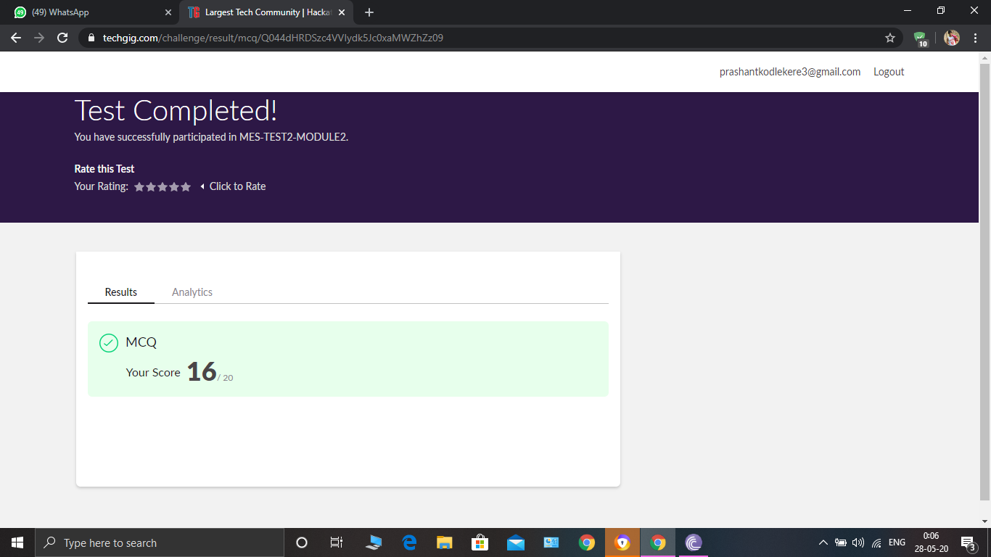

MICROCONTROLLERS AND EMBEDDED SYSTEM(MES) Internals was conducted. A total of 20 questionS were Multiple Choice Questions.

The above snapshot is the result sheet which was mailed to us by the Techgig team.

Certification Course Details:

Course name:Python 3 for bigginners in2020(3rd and 4th section)

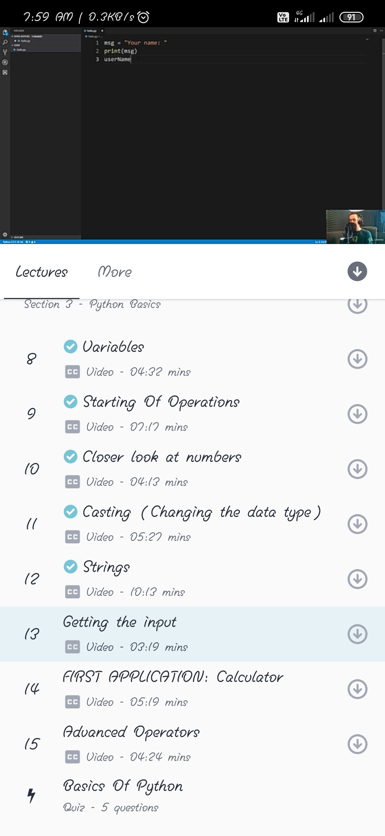

In section 3,I have learnt about casting(changing the datatype) and strings,and about getting the input and first application(calculator) and about advanced operation.

In section 4, I have learnt about logical operators and conditions and its applications.

Coding Challenges Details:

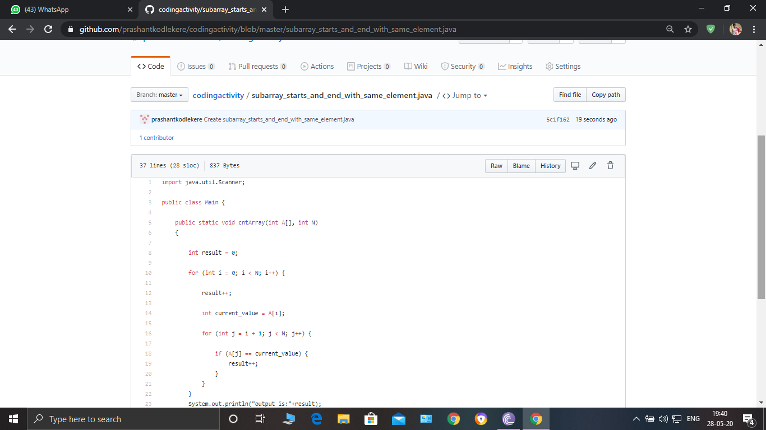

**The question I took to code is:**

**Java program to print the total number of subarray of the given array that starts and ends with same element.**

Code: The above snapshot is the code which I have uploaded in my Github repository.